Really Easy Wrist Warmers

These really easy wrist warmers are great for beginners as they knit up quick and are knitted in Garter Stitch (every row knit) throughout.

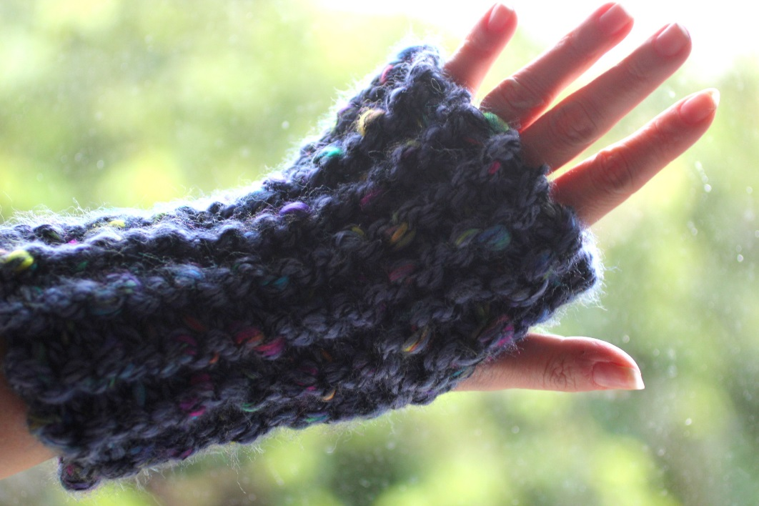

Yarn: Designer Yarns Choices Rumba Tweed 1 x 200g ball
Needles: 12mm

Cast on 16 stitches
Working in Garter Stitch (every row knit), work 22 rows
Cast off

Sew the cast on and cast off edges together leaving a gap for your thumb

The copyright to this pattern belongs to Kath Foster. This pattern is free for you to enjoy but I respectfully request that you do not use this pattern for your personal financial gain.

